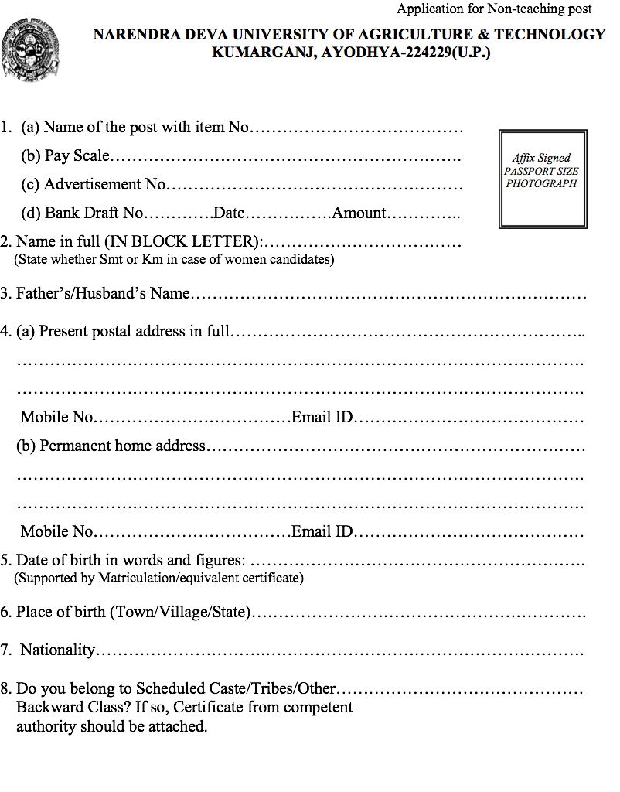

9. Give particulars of all the examinations passed and qualifications obtained (Commencing with the matriculation or equivalent examination and duly supported by attested copies of the certificates/degrees and mark sheets)
Sl.  No. | Examination Passed | Div./ OGPA | % of marks obtained | Subject | Year | Board/ University | Distinction achieved
1.
2.
3.
4.
5.
7.
8.

10. Participation in Co-curricular activities and distinctions achieved alongwith evidence
…………………………………………………………………………………………
………………………………………………………………………………………
…………………………………………………………………………………………
…………………………………………………………………………………........
11. The details about the previous and present employment/work experience:
Sl. No. | Post held | Period with dates |  |  | Scale of pay | Nature of duties in brief | Employer
 |  | From | To | Total period
1. | 2. | 3. | 4. | 5. | 6. | 7. | 8.

12. Additional Remark: Applicants may mention here any special qualification or experience, not covered above. If the space below insufficient for this purpose, please give full particulars on a separate sheet of a paper and attach it to this application form inserting here a reference to the sheet attached.

13. Have you ever been arrested/prosecuted/convicted by a Criminal Court? If so, give details.
…………………………………………………………………………………………
…………………………………………………………………………………………
14. In case selected for appointment, will you please execute a bond to serve this University for a specified period?
…………………………………………………………………………………………
…………………………………………………………………………………………
15. Give particulars of two responsible persons who are familiar with work & conduct.
Sl.  No. | Name | Occupation or position | Address
1.
2.

16. Declaration to be signed by the Candidate:
“I herby declare that the entries in this application form are true to the best of my knowledge and belief and also that I have not concealed any fact or withheld any information regarding my past service and records and that if any of the information’s give above is found to be false or incorrect or that if any thing is found to have been concealed, I will be disqualified for selection or if appointed, will be liable to termination without any notice or compensation”.
PLACE……………………… SIGNATURE……………….............

DATE………………………. FULL NAME………...……………..
&
ADDRESS………………………….
Remarks of the Present Employer
(In the case of those who are already in service)

The applicant Sri/Smt./Km./Dr……………………………………………………….is holding a permanent/ temporary post of…………………………………………………………. in scale of pay and gratuity Rs…………………… from …………… ………to……………… and his/her present basic pay is Rs………………………………….per month. His/her application is forwarded and he/she will be relieved in case he/she is selected for the post applied for:
Date……………………
Place…………………..
Name Designation of the Office (With official seal)

